Lab 07 - Installing Postfix and Dovecot
Table of Contents
Introduction 1
Updating DNS Server 2
Configure Deployed Server 3
Install Postfix 4
Install Dovecot 5
Configure Thunderbird 9
Secure Email 15
Add Rules for Mail Services for Outside/Nagios Check 18

Introduction
This week’s lab will introduce creating a mail server, using Postfix. There are several other options for mail servers such as Sendmail, but Postfix offers better features and is easier to maintain. The goal of this lab is to add this mail server to the network of servers and be able to send messages across the network to classmates.
The table below summarizes the packages used to set up the mail server, and the protocols each package oversees.

Note: this table can be valuable in troubleshooting issues encountered in the lab.

Package | Protocols | Ports
Postfix | SMTP | 25, 587
Dovecot | IMAP  POP3 | 143, 993  110, 995

Updating DNS Server
To successfully send emails, an additional DNS entry needs to be added. This entry tells entities on the network where mail directed toward your domain (studentXX.230.com) should be directed. Follow the steps below on the external DNS server (ns1) to create this new entry. The internal DNS (ns2) will also be modified after the external DNS (ns1) is modified. Make sure everything from the previous labs is working.

- Log into your existing external DNS server (ns1).
- Open file /etc/bind/db.studentXX.230.com.
- Create a new record above your previous entries.
studentXX.230.com. IN MX 10 mail.studentXX.230.com.
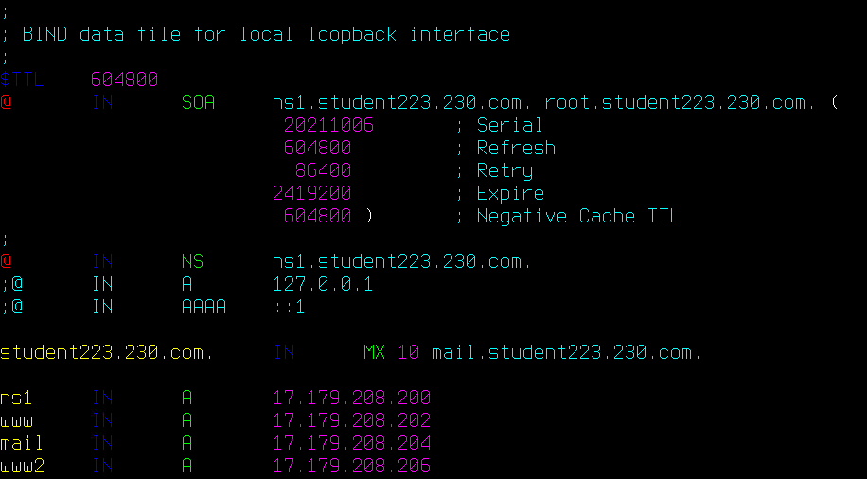

- Increment the serial number in the upper portion of the file.
- This should be done any time you modify your DNS records
- Increment the last number by 1.

- Reload the DNS configuration and clear your DNS cache.
  - sudo systemctl reload bind9
  - resolvectl flush-caches
- Log into your existing internal DNS server (ns2).
- Open file /etc/bind/db.studentXX.230.com.
- Create a new record above your previous entries.
studentXX.230.com. IN MX 10 mail.studentXX.230.com.

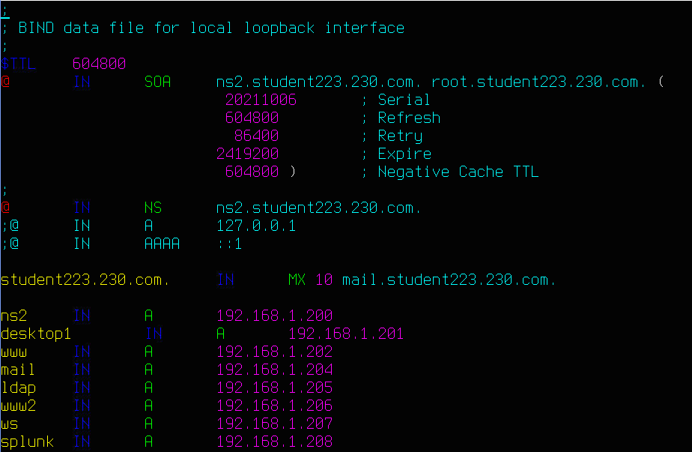
- Increment the serial number in the upper portion of the file.
- Reload the DNS configuration and clear the DNS cache.
  - sudo systemctl reload bind9
  - resolvectl flush-caches

Configure Deployed Server
- VM name: cpre230_[netid]_mail
- Username and password: cpre230
- Before powering on the mail server, set the MAC address reservation on the pfSense box for the mail server. Use the table below. Refer to previous labs on how to do this step.

MAC address | IP address | Hostname | Description
From vSphere client | 192.168.1.204 | mail | Ubuntu server - mail

- Power on the mail server. Verify the correct IP address was assigned using ip addr.
- Hostname should be mail.
sudo hostnamectl set-hostname mail
- Update and upgrade the mail server with apt.
  - If the machine is unable to update itself, it means there is a networking problem that needs to be fixed before moving on.
- Verify that the DNS entries are properly set by performing a DNS MX query on studentXX.230.com.
  - Run the following command to perform the lookup.
dig MX studentXX.230.com @199.100.16.100
  - The MX argument specifies the type of DNS record to query, in this case "mail exchange". When it's not specified, dig queries A records by default.
  - The @199.100.16.100 argument specifies which server to query. When it's not specified, dig queries the system's default nameserver. On your system, the default nameserver should be a systemd caching resolver at 127.0.0.1.
  - Should look like the figure below:
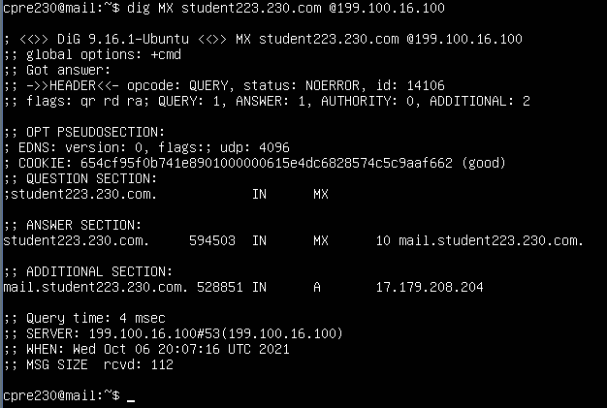

  - Take a screenshot.
  - Note: if you made a mistake in your MX configuration, it may take a few hours for the new configuration to propagate to 199.100.16.100. In the meantime, you can check your work by running just dig MX studentXX.230.com
The screenshot needs to be of the query of 199.100.16.100 to earn points.

Install Postfix
Postfix is a SMTP utility that is used to send mail throughout the internet. We will be configuring it first without SSL encryption so that you can view raw packets with Wireshark, then will upgrade our installation to use SSL.
- Use the following command to install postfix.
  - sudo DEBIAN_PRIORITY=low apt install postfix
  - Now, you will be asked a series of questions - answer as stated below.
- Type of configuration: Internet Site
- System mail name: studentXX.230.com
- Root and postmaster recipient: cpre230
- Accepted destinations:
mail.studentXX.230.com, studentXX.230.com, localhost
- Synchronous update : No
- Local networks:
XX.XX.XX.0/24 127.0.0.0/8
- Mailbox size: 0
- Local address extension: +
- Protocols to use: IPv4 only
To run the configuration wizard again in case a parameter was mistyped, use the command:
sudo dpkg-reconfigure postfix
- Restart postfix.
sudo systemctl restart postfix

Install Dovecot
- Install Dovecot IMAP and POP3 servers.
  - First, sudo apt update
  - Then, sudo apt install dovecot-core dovecot-imapd
  - If you come across these prompts, just keep the defaults and continue
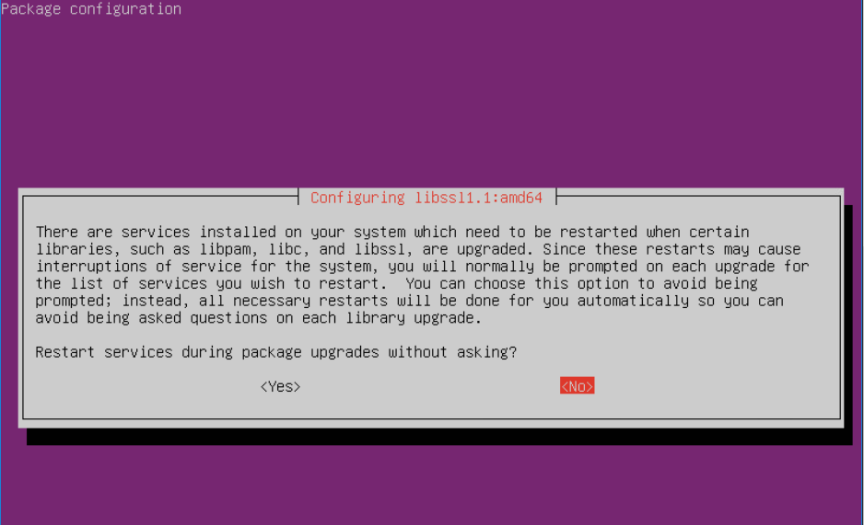
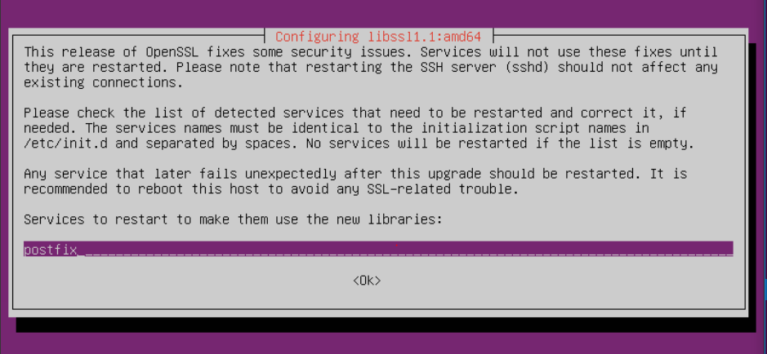
  - If you see an error like the one below after installing dovecot, ignore it and proceed to step 2
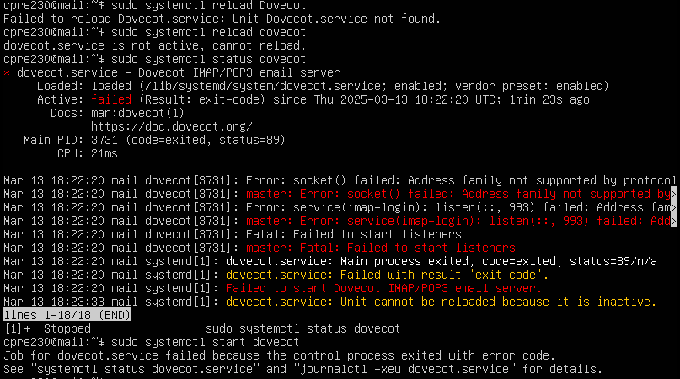

- Add the following line to the bottom of the /etc/dovecot/dovecot.conf file:
listen = *
- Run sudo systemctl restart dovecot to apply changes
- Install dovecot-pop3d sudo apt install dovecot-pop3d
- Reboot your machine
- Set up folder creation. This will enable your mail client to create folders it doesn’t have, like Sent and Trash.
  - Open /etc/dovecot/conf.d/15-mailboxes.conf
  - Edit to match the following screenshot:
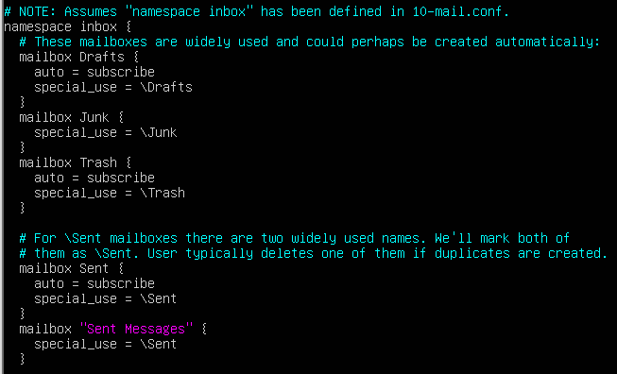
- Allow plaintext authentication (only for demo purposes).
  - Open /etc/dovecot/conf.d/10-auth.conf.
  - Uncomment the disable_plaintext_auth line and change yes to no.
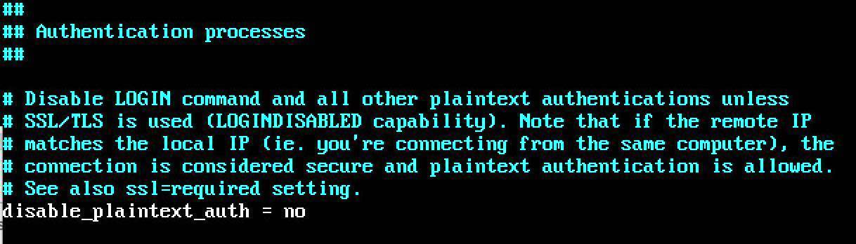
  - Open /etc/dovecot/conf.d/10-ssl.conf.
  - Change ssl = yes to ssl = no.
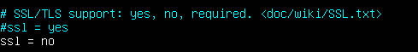

- Start dovecot.
sudo systemctl start dovecot
- Test that it is working.
telnet mail.studentXX.230.com pop3
- Type quit to exit.
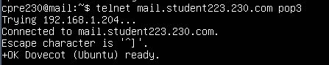

- Install the net-tools package with sudo apt install net-tools then run the command netstat -tnl to verify the appropriate ports are open (110 for pop3 and 143 for imap).
  - Take a screenshot.
- Now make two temporary users to send mail between. Create a user cpre230a with the password cpre230 and a second user cpre230b with the password cpre230. Recall that the adduser command can be used to create users.
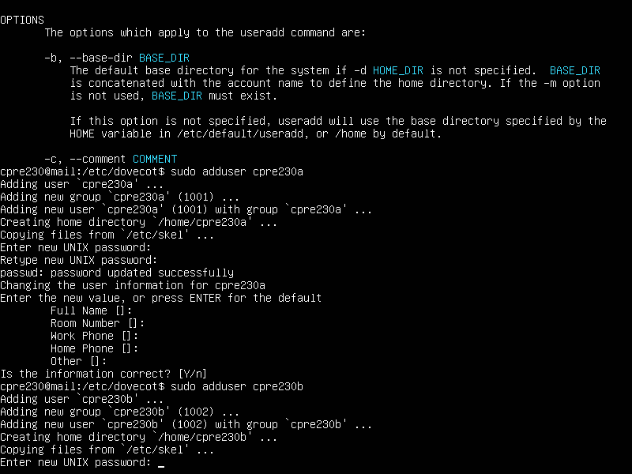

- Test the email server to see if it is working. You will do this at the command line to verify your users work. First, you will test sending a message, and then you will test reading a message. Type the following commands. You should get a response from the server after each command, except when entering your subject and message.

telnet mail.studentXX.230.com 25
helo studentXX.230.com
mail from: <cpre230a@studentXX.230.com>
rcpt to: <cpre230b@studentXX.230.com>
data
Subject: put a subject here

Enter whatever you want to send as a message.
Put a single . on a line by itself to end your message
.
quit
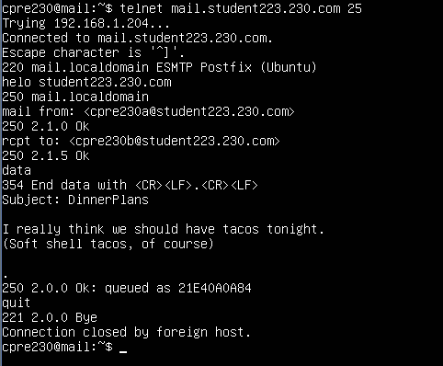

  - Take a screenshot of the transaction for your lab submission.
- Now you will test reading the message you just sent by running the following commands.
telnet mail.studentXX.230.com 110
USER cpre230b
PASS cpre230
LIST
RETR 1
QUIT
  - Again, take a screenshot of this for your lab submission
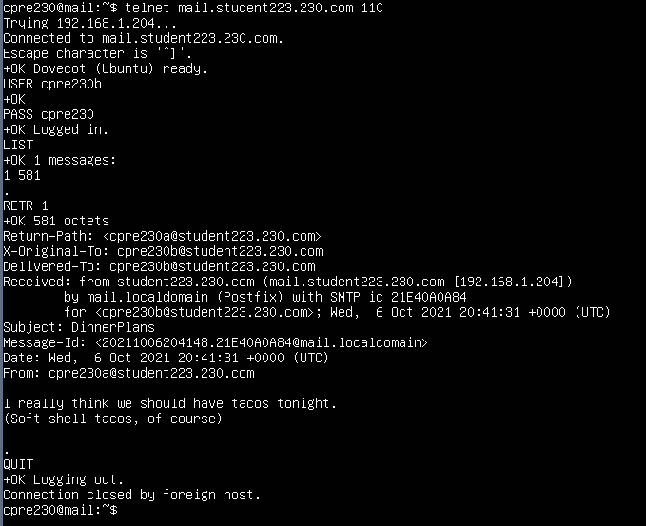
- In order to secure our server, we will eventually need a SSL certificate. Before we generate our self-signed certificate, we need to edit a few configuration settings.
  - Open /usr/share/dovecot/dovecot-openssl.cnf.
  - Set the organizationalUnitName and commonName to mail.studentXX.230.com
  - Set the emailAddress to postmaster@studentXX.230.com.

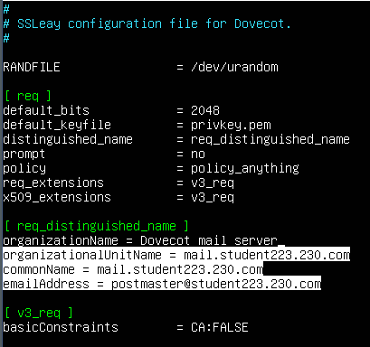
  - Generate the certificate by running the following commands.
cd /usr/share/dovecot
sudo mkdir /etc/dovecot/ssl
sudo ./mkcert.sh
- Now we will view our self-signed certificate to verify its contents. First you will just cat the file and see the base64 encoding. Then, you will read the file and see the format of the X.509 certificate that we discussed in class.
  - View the contents of the certificate file with the following commands.
cd /etc/dovecot/ssl
sudo cat dovecot.pem
  - Take a screenshot of this for your lab submission.
  - Now you will display the information in a format that humans can read.
sudo openssl x509 -in dovecot.pem -noout -text | less
  - Take a screenshot of each of the pages. Use the spacebar to advance by one page in less.

Configure Thunderbird
To further test our mail server, we will use Thunderbird as a mail client. Use your desktop machine from Lab 1 for this part of the lab.
- Do an update and upgrade (this is important):
sudo apt update
sudo apt upgrade
- Open Thunderbird. It should be in the dock, or you can search in "Activities". (If you can't find Thunderbird, install it with sudo apt install thunderbird.)
- When you open Thunderbird, you will be prompted with a screen that says, “Set Up Your Existing Email Address”.
- Click "Configure Manually" after you enter the name, email address, and password. You will need to edit nearly every field to match the screenshot below. Replace studentXX.230.com with your own student number. Click “Re-test‘ to check for any typos. When you are ready, click “Done”
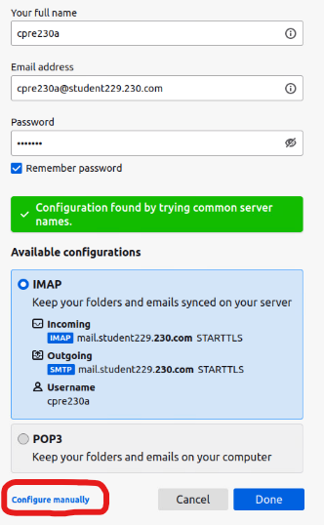

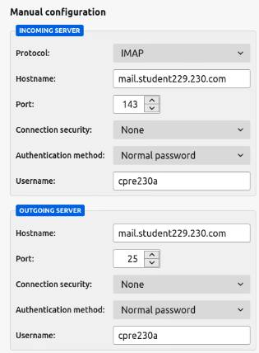

  - Because we are connecting using unencrypted protocols, we will receive a warning telling us we need to acknowledge the risks before continuing - check the "I understand the risks" box and continue. We will fix this warning soon.
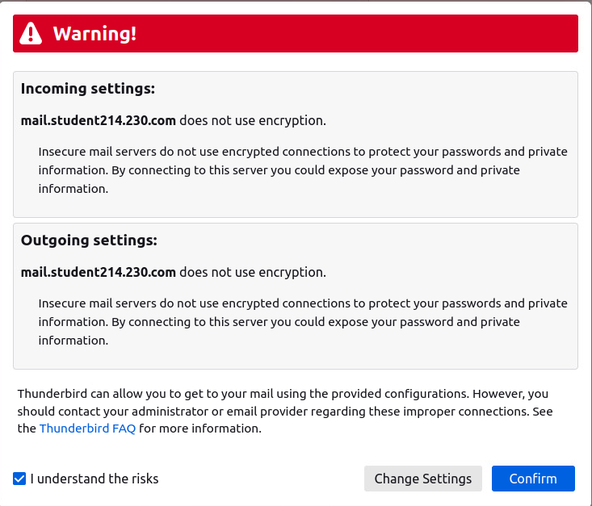
If you receive an error, “Unable to log in at server. Probably wrong configuration, username or password”, login to your mail server and restart dovecot, postfix, and reboot. If you still have issues, contact a TA after trying to troubleshoot a potential misconfiguration in your files.

- Add the cpre230b account.
  - Underneath “Set Up Another Account”, Click "Email". You may need to click on "cpre230a…" on the left side to make this option appear.
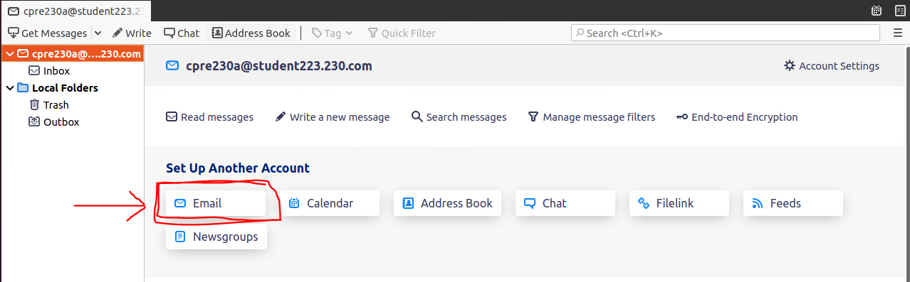
  - Follow the steps above to set up the account.

- Wireshark
  - You can now send and receive your email from one account cpre230a to cpre230b. Run Wireshark to capture your traffic before you send your test messages.
  - Start Wireshark listening on ens160 (double click on this interface).
  - Filter your capture in Wireshark for imap by typing into the filter bar above the capture.
  - In Thunderbird, send your test email messages. One message from cpre230a to cpre230b and another from cpre230b to cpre230a. If you look through the packets in Wireshark, you should be able to see your message being received in plaintext.
  - Take a screenshot of the imap packet capture with your plaintext information highlighted in the packet.
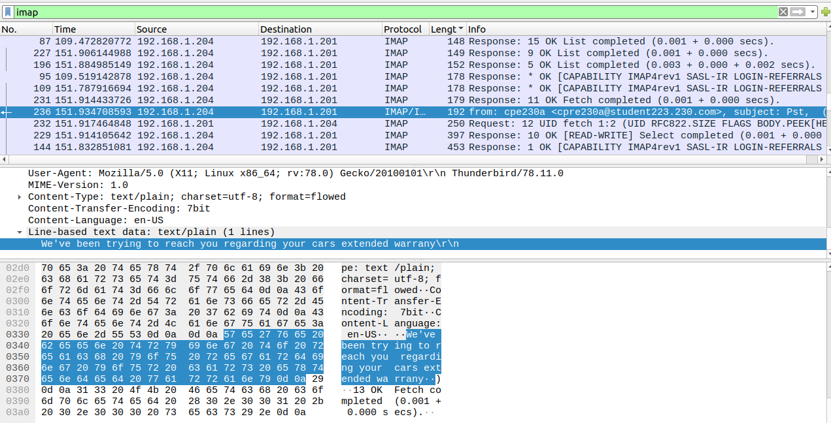

  - Look through the Wireshark capture and notice how you can see your email message in plaintext. You might notice that the password appears to be encoded in base64, but not encrypted. To test this, do the following:

      - Find the Request with Base64 encoded data
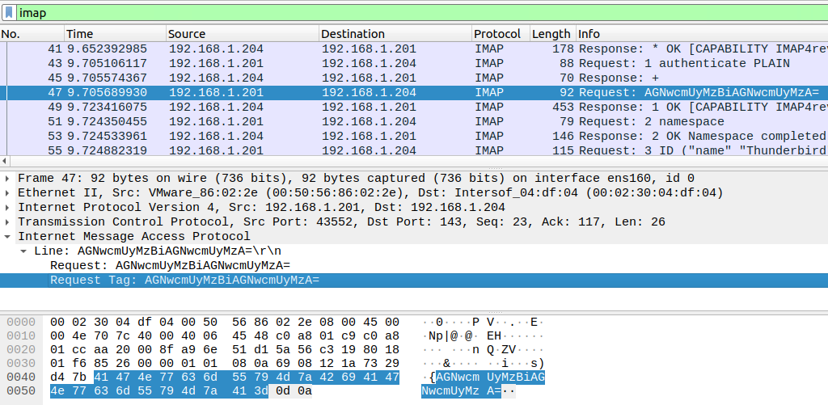
      - Open the IMAP information in the second window
      - Click on the packet and expand the “Internet Message Access Protocol” field
      - Right-click on the Line that says “Request Tag”
      - Select Copy → Value
      - Open Firefox and search for a base64 decoder
      - Past the value into the decoder tool
      - Take a screenshot of the plaintext username and password to include in your lab report.

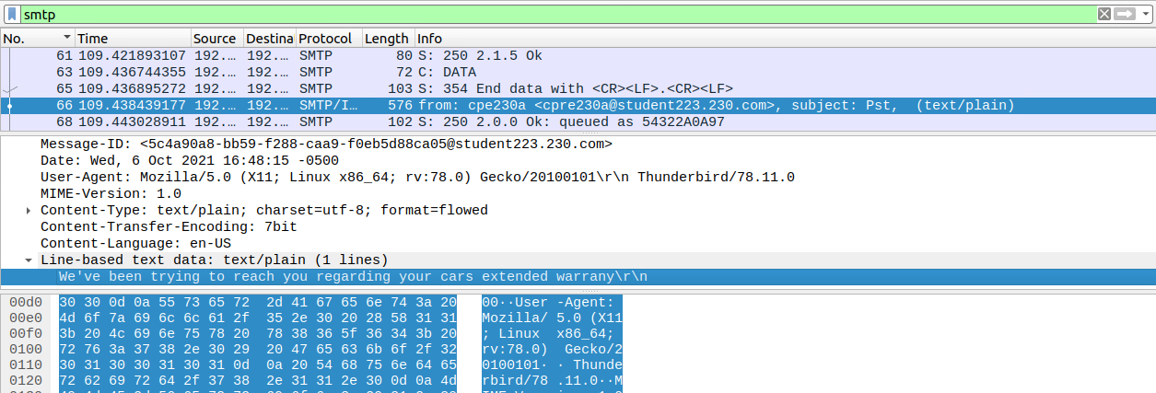
  - Now, filter your capture in Wireshark for smtp. You do not need to send additional email messages. All you need to do is change the filter from imap to smtp and press enter.
  - Find the packet with your plaintext information being sent across the network. (Hint: It is likely a packet with a length of about 500+) Take a screenshot.
- Now provide a screenshot of your inbox, showing your various test messages, confirming that they have been sent and received.
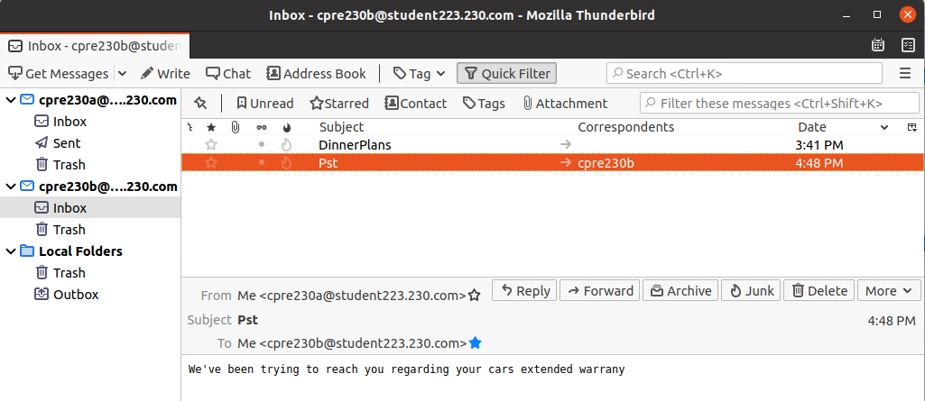

Secure Email
As seen in Wireshark, anybody on the wire can read the contents of emails because they are transmitted in plaintext. Even our password can be seen by the world if they are willing to decode base64. To mitigate this, we will configure IMAP to use SSL.
- Back on your new mail server, edit /etc/dovecot/conf.d/10-ssl.conf.
  - Change ssl = no to ssl = yes.
  - Set ssl_cert and ssl_key to the certificate you created earlier in the ssl directory.
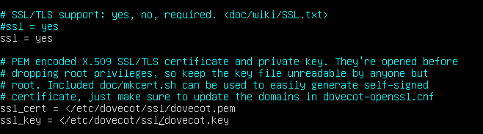

- Edit /etc/dovecot/conf.d/10-auth.conf.
  - Disable plaintext auth.
- Edit /etc/dovecot/conf.d/10-master.conf.
  - Search for the service auth block (around line 100) and edit the unix_listener block as follows:
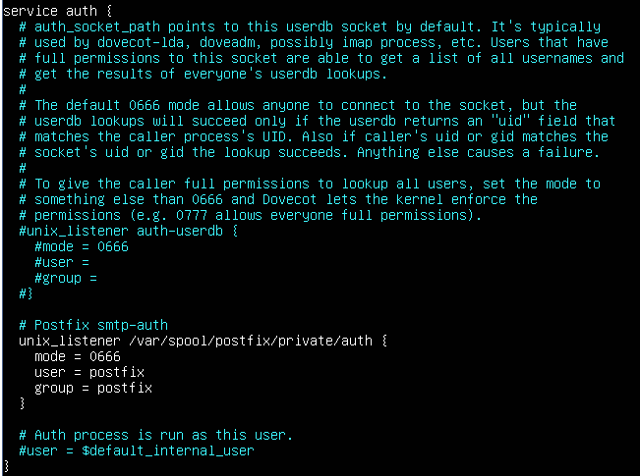
- Restart dovecot.
sudo systemctl restart dovecot
- Open /etc/postfix/main.cf and update it to match the following (add the lines that don’t exist).
smtpd_tls_cert_file=/etc/dovecot/ssl/dovecot.pem
smtpd_tls_key_file=/etc/dovecot/ssl/dovecot.key
smtpd_use_tls = yes
smtpd_tls_auth_only = yes
smtpd_sasl_type = dovecot
smtpd_sasl_path = private/auth
smtpd_sasl_auth_enable = yes
smtpd_tls_security_level=may
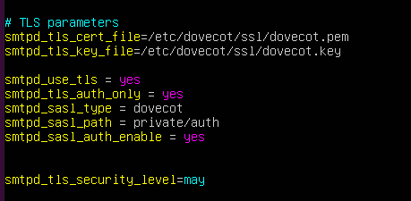
- Open /etc/postfix/master.cf.
  - Uncomment the 5 lines and edit the client restriction line as shown below.
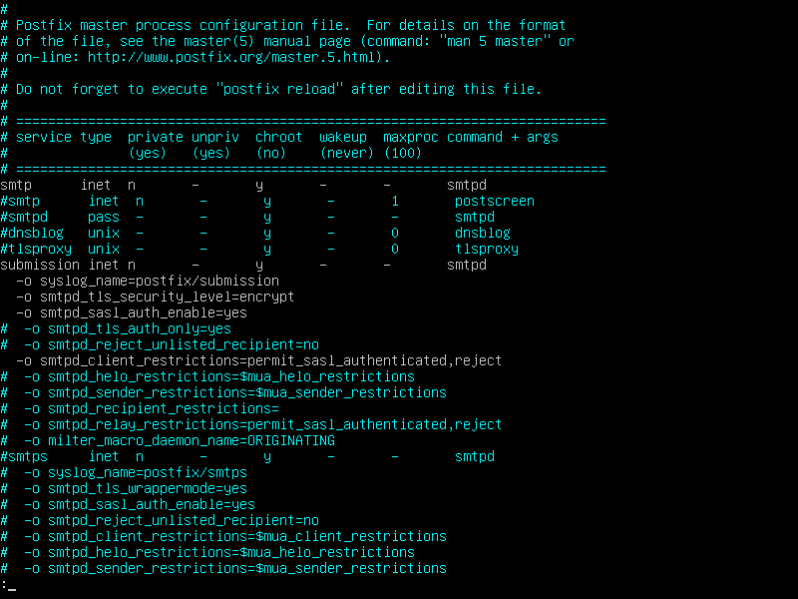
- Restart postfix.
sudo systemctl restart postfix
- Back on your desktop machine, modify the server settings for the two accounts in Thunderbird to now use SSL/TLS for IMAP. In Thunderbird, go to the upper right corner and click “Account Settings”. Click on the cpre230a account, and towards the bottom click “Account Actions” → “Remove Account”. Repeat this process for cpre230b.

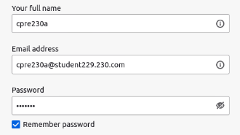
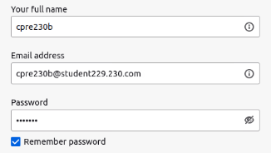
- After deleting both accounts, create two new accounts as shown below:
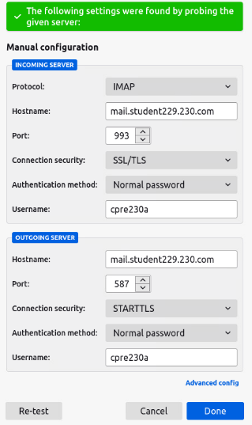
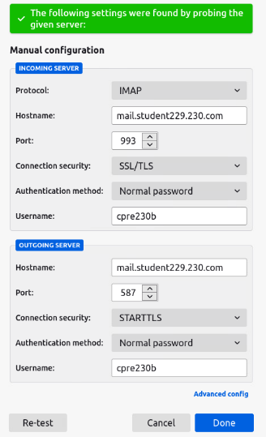
- You will now be presented with a dialog box telling you that you are going to use a self-signed certificate. View the certificate and then add it to your exceptions by clicking "Confirm Security Exception". (Note: when you click “View”, you may have to manually go to the new Thunderbird window/tab to see the certificate.) You will need to confirm two exceptions. If you are not presented with the security exception dialog box, click “Get Messages”. You may also see it when you try to send more email messages.
- Now send more emails between the two test users, again while capturing packets with Wireshark. What do we now see?
  - If Thunderbird fails to send an email with an unknown error, switch to the main Thunderbird window and you might see a security exception prompt that you need to confirm. Try sending again after confirming the exception.
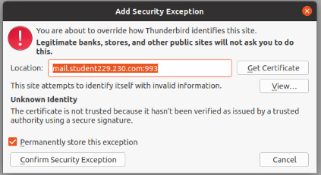

  - In Wireshark, filter for traffic ONLY on port 587 and submit a screenshot of the Wireshark traffic with this filter. (Be sure to hit enter and verify you are looking at packets on port 587): tcp.port==587

  - In Wireshark, filter for traffic ONLY on port 993 and submit a screenshot of the Wireshark traffic with this filter. (Be sure to hit enter and verify you are looking at packets on port 993): tcp.port==993

  - Try looking at the packets in the wireshark captures. You shouldn’t be able to see the username or password in clear text anymore.

Add Rules for Mail Services for Outside/Nagios Check
- From your desktop machine open Firefox and open the pfSense web configurator. If you don’t remember how to do this, return to Lab 04.

- Add NAT rules in pfSense that allows the outside world, as well as Nagios, to check both sending and receiving email as cpre230a and cpre230b
  - You can use the instructions from Lab 05 to determine what fields to complete, but you will need to know what protocol to use, as well as the correct IP addresses and ports.
  - Note: The port for the secure outgoing mail service (SMTP) is NOT SMTP/S in pfSense. PfSense uses a deprecated port of 465. You need the SUBMISSION port of 587. That is the standard. SUBMISSION should be an option, but alternatively you can enter your own port by selecting the “other” category and 587.

- Because you want the outside world to have access, you won’t limit the source to just the Nagios machine’s IP. Determine how to allow all machines to connect to the mail server for sending and receiving email. If you have questions, you can ask your TA for help. However, you should begin to be able to think through these options on your own. Include a screenshot of your successful NAT rule.

- Go to Nagios and check if it can see your mail server
  - If you can’t remember how to get to Nagios, you can find the instructions in Lab 05
  - You may have to adjust your firewall’s NAT rules if you are unsuccessful.

- Include a screenshot of your successful NAT rules.

- Include a screenshot of the Nagios status showing all mail services are functioning for your domain.

